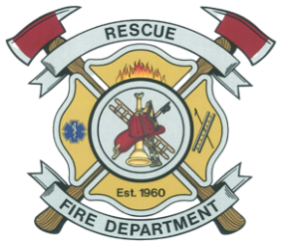

Special Meeting
Agenda
September 21, 2026, 6:00 P.M.
5221 Deer Valley Road, Rescue, CA 95672
(P.O. Box 201)
(530) 677-1868

NOTE
If you need a disability-related modification or accommodation, including auxiliary aids or services, to participate in this meeting, please get in touch with the Board Clerk at (530) 677-1868 at least two (2) days before the meeting.

- CALL TO ORDER

- ROLL CALL/ESTABLISH QUORUM

- FLAG SALUTE

- APPROVAL OF AGENDA

- PUBLIC COMMENTS and PUBLIC FORUM
This item is for the public to discuss matters not on the agenda and within the jurisdiction of the Rescue Fire Protection District or to discuss the closed executive session item. Comments shall be limited to five minutes per person and twenty minutes for all comments unless otherwise authorized by the Board.

- NEW BUSINESS
  - Remodel/Rebuild Station 83

- GOOD TO THE ORDER

- Closed Session
  - Pursuant to Government Code Section 54956.8, Acquisition of Real Property

- RECONVENE TO REPORT ACTION TAKEN

- NEXT SCHEDULED MEETING / AGENDA ITEMS
Regular Board Meeting October 14, 2026

- ADJOURNMENT

